|  |  |
| --- | --- |
| Product name | Confidentiality Level |
| Internal disclosure |
| HEY2-W09 | Total pages: 16 |

**HONOR HEY2-W09 def,spcseas Upgrade Guide**

|  |  |  |  |
| --- | --- | --- | --- |
| **Prepared by** | Wang Yanzhao 00013378  Wu Guoping 00013208 |  |  |
| **Review by** | Li Shubin 00013108 |  |  |
| **Approved by** |  |  |  |

**Revision History**

| Date | Version | Section | Description | Author |
| --- | --- | --- | --- | --- |
| 2021-03-06 | V1.0 |  | First draft | Wang Yanzhao 00013378  Wu Guoping 00013208 |
| 2021-04-07 | V1.1 | 6, 8 , 9 | Added screenshots (Chinese) for the upgrade steps | Wang Yanzhao 00013378  Wu Guoping 00013208 |
|  |  |  |  |  |
|  |  |  |  |  |
|  |  |  |  |  |

**Contents**

**Revision History** 1

1 Upgrade Precautions 3

**1.1 Precaution1** 3

**1.2 Precaution 2** 3

2 Version Requirement 3

**2.1 Tablet version requirement** 3

**2.2 Software requirement** 3

3 Upgrade Environment 4

4 Starting the Upgrade - SD Card Method 4

**4.1 Manually start the upgrade from the project menu.** 4

**4.2 Force the upgrade by pressing the shortcut buttons to enter the Upgrade mode.** 4

**4.3 Start the upgrade by commands from equipment.** 4

5 Number of Upgrades Required for Production Line-SD Card Method 4

6 Typical Directory of SD Card Upgrade Packages in SD/OTG 5

**6.1 All 3 packages are in the dload folder:** 5

**6.2 The base package is in the root folder of dload:** 5

7 Instructions for Command Triggered Upgrades 5

8 Board-to-Upgrade Instructions (3 Packages in One Go) 5

**8.1** **SD card upgrade triggered from the project menu** 5

**8.2** **SD card upgrade forced by shortcut buttons** 6

**8.3** **Normal OTG upgrade triggered from the project menu** 7

**8.4** **OTG upgrade forced by shortcut buttons** 9

9 Upgrade-to-Upgrade Instructions (3 Packages in One Go) 10

**9.1** **SD card upgrade triggered from the project menu** 10

**9.2** **SD card upgrade forced by shortcut buttons** 11

**9.3** **Normal OTG upgrade triggered from the project menu** 12

**9.4** **OTG upgrade forced by shortcut buttons** 14

**9.5** **Reset tablet** 15

10 Verification and Troubleshooting 15

**10.1 Version check** 15

**10.2 Basic function check** 15

**10.3 Troubleshooting upgrade issues** 15

**10.4 Using the "at" command and writing customized information** 15

# Upgrade Precautions

## **1.1 Precaution1**

Read the feature description before performing the upgrade.

1. Software version

Ensure that the tablet is running on stock, unmodified Honor firmware, otherwise the upgrade may fail, or unknown errors may occur.

Do not attempt to upgrade your tablet with any customized firmware intended for countries outside your country of residence, otherwise the upgrade may fail, or unknown errors may occur.

1. Hardware version

This upgrade package is intended for the HEY2-W09 model(s) only, using it to upgrade other s may cause boot failures.

## **1.2 Precaution 2**

1. Updating your tablet will erase all user data. Back up your data before the upgrade. Ensure that the **battery is charged to more than 30%** at the beginning of the upgrade.

2. As the single SIM and dual SIM versions of MAGIC OS or later systems are not interchangeable, be sure to use the correct update package. In case a wrong version was used, contact your local Honor service center.

3. Note that the cota subnetwork packages for single /dual SIM versions are also different.

# Version Requirement

## **2.1 Tablet version requirement**

The software version of the tablet must not be higher than the upgrade package.

## **2.2 Software requirement**

|  |
| --- |
| **Upgrade software list** |
| \---dload  | update_sd_base.zip  | HEY2-W09_def_spcseas  | update_sd_cust_HEY2-W09_def_spcseas.zip  | update_sd_preload_HEY2-W09_def_spcseas_R2.zip |

Both the tablet and the upgrade package contain a customization package and a preloaded package. The names of these packages indicate their intended model and Vendor Country Info. For the upgrade to be successful, this information on all four files names (in the tablet and in the upgrade package) must match. The directory where the upgrade package is copied to in the USB flash drive or SD card must be the same as the directory described above.

# Upgrade Environment

We recommend using the OTG adapter + flash drive method first. The SD card method can also be used if the tablet has an SD card slot.

* + - 1. Before updating using the OTG adapter + flash drive method, check if the flash drive is working correctly and has more than 8GB of available space. We recommend using flash drives from well-known brands for this process. Please ensure that the OTG adapter matches the port type of the tablet. The adapter shown below only works with s that have Type-C ports.

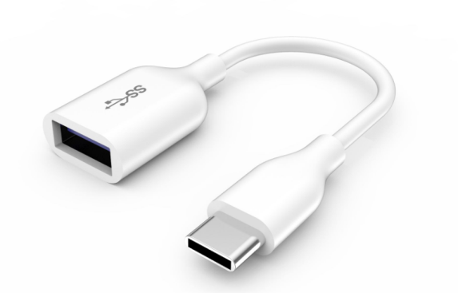

Type-C-2-OTG

* + - 1. If you are upgrading with the SD card method, check whether the SD card is working correctly and has more than 8GB of space available before proceeding. We recommend using flash drives from well-known brands for this process.

# Starting the Upgrade - SD Card Method

## **4.1 Manually start the upgrade from the project menu.**

## **4.2 Force the upgrade by pressing the shortcut buttons to enter the Upgrade mode.**

## **4.3 Start the upgrade by commands from equipment.**

# Number of Upgrades Required for Production Line-SD Card Method

SD card upgrades can be done either in one go (the base package, customization package, and preloaded package applied at once at UT) or two goes (apply the base package first at UT, then apply the other packages after CW has written devmodel and vendorcountry).

**Note: The production line should consult with the R&D underlying software manager, upgrade module responsible and equipment responsible to determine how the SD card upgrade should be done.**

# Typical Directory of SD Card Upgrade Packages in SD/OTG

## **6.1 All 3 packages are in the dload folder:**

\---dload | update_sd_base.zip | update_sd_cust_HEY2-W09_def_spcseas.zip | update_sd_preload_HEY2-W09_def_spcseas_R2.zip

## **6.2 The base package is in the root folder of dload:**

\---dload | update_sd_base.zip | HEY2-W09_def_spcseas | update_sd_cust_HEY2-W09_def_spcseas.zip | update_sd_preload_HEY2-W09_def_spcseas_R2.zip

# Instructions for Command Triggered Upgrades

If the SD card upgrade is triggered by commands from equipment, make sure the directory of the upgrade packages in the SD card or flash drive is correct:

1. For upgrades done in one go, the directory of the 3 packages copied into the SD card/flash drive must be the same as the directory described in Section 6.1.

2. For upgrades done in two goes, the directory of the 3 packages copied into the SD card/flash drive must be the same as the directory described in Section 6.2.

# Board-to-Upgrade Instructions (3 Packages in One Go)

## **SD card upgrade triggered from the project menu**

Step 1: Find an SD card (preferably from well-known brands) with 8GB or more space available.

Step 2: Format this card (optional) to exFAT, NTFS, or FAT32 file system (exFAT is recommended).

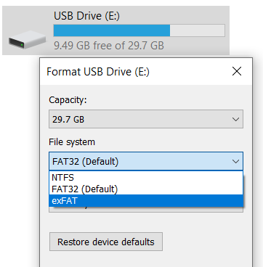

Step 3: Copy the base package, the customization package, and the preloaded package to the dload folder in the root of the SD card (as shown in 6.1).

Step 4: Insert the SD card into the tablet, then type in ()()2846579()() on the tablet’s [Calculator](https://cn.bing.com/dict/search?q=Calculator&FORM=BDVSP6&cc=cn) [interface](https://cn.bing.com/dict/search?q=interface&FORM=BDVSP6&cc=cn) -> Project menu -> Software Upgrade -> Memory Card Upgrade -> OK.

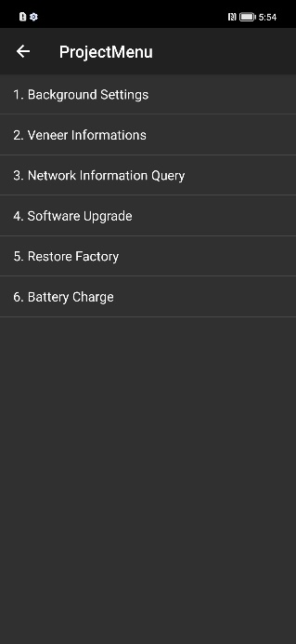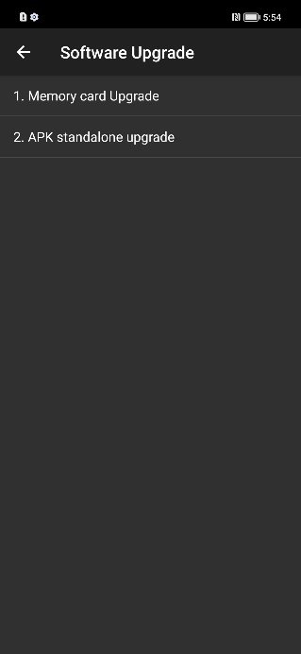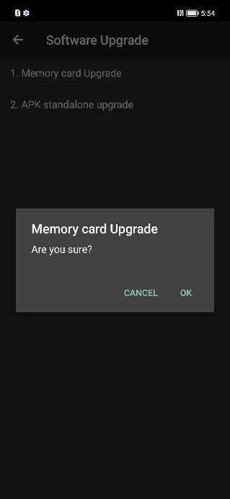

Step 5: Wait while the upgrade is being installed. The tablet will automatically reboot when the installation is complete. Note: Keep the SD card inserted until the screen shows "Update success".

For MAGIC OS, the following screens will be shown:

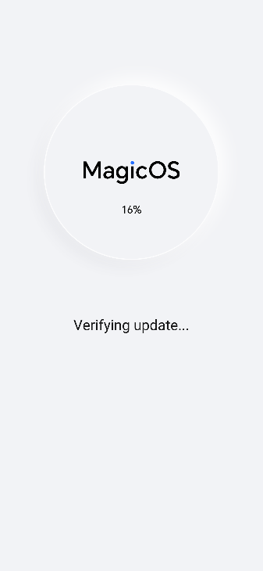手机屏幕截图

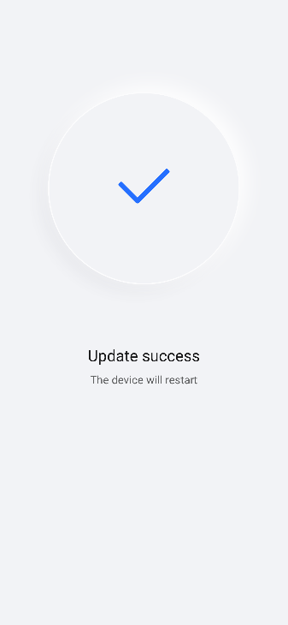

## **SD card upgrade forced by shortcut buttons**

Step 1: Find an SD card (preferably from well-known brands) with 8GB or more space available.

Step 2: Format this card (optional) to exFAT, NTFS, or FAT32 file system (exFAT is recommended).



Step 3: Copy the base package, the customization package, and the preloaded package to the dload folder in the root of the SD card (as shown in 6.1).

Step 4: Insert the SD card into the tablet while it is powered off, then press the Volume up button and the Power button simultaneously to go into the recovery menu and select Update mode --> Input yes, Enter update mode --> Memory card/OTG update mode to begin the upgrade.

Step 5: Wait while the upgrade is being installed. The tablet will automatically reboot when the installation is complete. Note: Keep the SD card inserted until the screen shows "Update success".

For MAGIC OS, the following screens will be shown:

手机屏幕截图

## **Normal OTG upgrade triggered from the project menu**

Step 1: Find a flash drive (preferably from well-known brands) with 8GB or more space available.

Step 2: Format this drive (ensure sufficient capacity, optional) to exFAT, NTFS, or FAT32 file system (exFAT is recommended).



Step 3: Copy the base package, the customization package, and the preloaded package to the dload folder in the root of the USB flash drive (as shown in 6.1).

Step 4: Connect the OTG adapter to the tablet, then the flash drive to the OTG adapter. Go to the tablet’s [Calculator](https://cn.bing.com/dict/search?q=Calculator&FORM=BDVSP6&cc=cn) [interface](https://cn.bing.com/dict/search?q=interface&FORM=BDVSP6&cc=cn) -> type in ()()2846579()() -> Project Menu -> Software Upgrade -> Memory Card Upgrade -> OK.



Step 5: Wait while the upgrade is being installed. The tablet will automatically reboot when the installation is complete. Note: Keep the OTG adapter and the flash drive firmly connected until the screen shows "Update success".

For MAGIC OS, the following screens will be shown:

手机屏幕截图

## **OTG upgrade forced by shortcut buttons**

Step 1: Find a flash drive (preferably from well-known brands) with 8GB or more space available.

Step 2: Format this drive (ensure sufficient capacity, optional) to exFAT, NTFS, or FAT32 file system (exFAT is recommended).



Step 3: Copy the base package, the customization package, and the preloaded package to the dload folder in the root of the USB flash drive (as shown in 6.1).

Step 4: With the tablet powered off, connect the OTG adapter to the tablet, then the flash drive to the OTG adapter. Press the Volume up button and the Power button simultaneously to go into the recovery menu and select Update mode --> Input yes, Enter update mode --> Memory card/OTG update mode to begin the upgrade.

Step 5: Wait while the upgrade is being installed. The tablet will automatically reboot when the installation is complete. Note: Keep the OTG adaptor and the flash drive firmly connected until the screen shows "Update success".

For MAGIC OS, the following screens will be shown:

手机屏幕截图

# Upgrade-to-Upgrade Instructions (3 Packages in One Go)

## **SD card upgrade triggered from the project menu**

Step 1: Find an SD card (preferably from well-known brands) with 8GB or more space available.

Step 2: Format this card (optional) to exFAT, NTFS, or FAT32 file system (exFAT is recommended).



Step 3: Copy the base package to dload in the root of the SD card, then copy the customization package and the preloaded package to a subfolder of dload (as shown in 6.2).

Step 4: Make sure that the tablet is written with the correct devmodel and vendorcountry.

Step 5: Insert the SD card into the tablet, then type in ()()2846579()() on the tablet’s [Calculator](https://cn.bing.com/dict/search?q=Calculator&FORM=BDVSP6&cc=cn) [interface](https://cn.bing.com/dict/search?q=interface&FORM=BDVSP6&cc=cn) -> Project menu -> Software Upgrade -> Memory Card Upgrade -> OK.



Step 6: Wait while the upgrade is being installed. The tablet will automatically reboot when the installation is complete. Note: Keep the SD card inserted until the screen shows "Update success".

For MAGIC OS, the following screens will be shown:

手机屏幕截图

## **SD card upgrade forced by shortcut buttons**

Step 1: Find an SD card (preferably from well-known brands) with 8GB or more space available.

Step 2: Format this card (optional) to exFAT, NTFS, or FAT32 file system (exFAT is recommended).



Step 3: Copy the base package to dload in the root of the SD card, then copy the customization package and the preloaded package to a subfolder of dload (as shown in 6.2).

Step 4: Make sure that the tablet is written with the correct devmodel and vendorcountry.

Step 5: Insert the SD card into the tablet while it is powered off, then press the Volume up button and the Power button simultaneously to go into the recovery menu and select Update mode --> Input yes, Enter update mode --> Memory card/OTG update mode to begin the upgrade.

Step 6: Wait while the upgrade is being installed. The tablet will automatically reboot when the installation is complete. Note: Keep the SD card inserted until the screen shows "Update success".

For MAGIC OS, the following screens will be shown:

手机屏幕截图

## **Normal OTG upgrade triggered from the project menu**

Step 1: Find a flash drive (preferably from well-known brands) with 8GB or more space available.

Step 2: Format this drive (ensure sufficient capacity, optional) to exFAT, NTFS, or FAT32 file system (exFAT is recommended).



Step 3: Copy the base package to dload in the root of the USB flash drive, then copy the customization package and the preloaded package to a subfolder of dload (as shown in 6.2).

Step 4: Make sure that the tablet is written with the correct devmodel and vendorcountry.

Step 5: Connect the OTG adapter to the tablet, then the flash drive to the OTG adapter. Go to the tablet’s [Calculator](https://cn.bing.com/dict/search?q=Calculator&FORM=BDVSP6&cc=cn) [interface](https://cn.bing.com/dict/search?q=interface&FORM=BDVSP6&cc=cn) -> type in ()()2846579()() -> Project Menu -> Software Upgrade -> Memory Card Upgrade -> OK.



Step 6: Wait while the upgrade is being installed. The tablet will automatically reboot when the installation is complete. Note: Keep the OTG adapter and the flash drive firmly connected until the screen shows "Update success".

For MAGIC OS, the following screens will be shown:

手机屏幕截图

## **OTG upgrade forced by shortcut buttons**

Step 1: Find a flash drive (preferably from well-known brands) with 8GB or more space available.

Step 2: Format this drive (ensure sufficient capacity, optional) to exFAT, NTFS, or FAT32 file system (exFAT is recommended).



Step 3: Copy the base package to dload in the root of the USB flash drive, then copy the customization package and the preloaded package to a subfolder of dload (as shown in 6.2).

Step 4: Make sure that the tablet is written with the correct devmodel and vendorcountry.

Step 5: With the tablet powered off, connect the OTG adapter to the tablet, then the flash drive to the OTG adapter. Press the Volume up button and the Power button simultaneously to go into the recovery menu and select Update mode --> Input yes, Enter update mode --> Memory card/OTG update mode to begin the upgrade.

Step 6: Wait while the upgrade is being installed. The tablet will automatically reboot when the installation is complete. Note: Keep the OTG adaptor and the flash drive firmly connected until the screen shows "Update success".

For MAGIC OS, the following screens will be shown:

手机屏幕截图

## **Reset tablet**

Go to Settings > System & updates > Reset > Reset tablet, tap "Reset tablet", then tap "Reset tablet" again to start the reset.

# Verification and Troubleshooting

## **10.1 Version check**

Go into Settings ->About tablet->Build number, verify that the installed version number matches the upgrade package.

## **10.2 Basic function check**

(1) Check if the tablet can 1. power on and boot into the operating system, 2. dial and place calls, 3. be turned off by long-pressing the power button.

(2) Check if all apps can run properly.

## **10.3 Troubleshooting upgrade issues**

If an issue cannot be resolved (without violating any precautions), please contact your local Honor service center.

## **10.4 Using the "at" command and writing customized information**

1 Make sure that USB drivers are installed on your PC.

2 Set the tablet port to Manufacture mode: in the home screen, go to the tablet’s [Calculator](https://cn.bing.com/dict/search?q=Calculator&FORM=BDVSP6&cc=cn) [interface](https://cn.bing.com/dict/search?q=interface&FORM=BDVSP6&cc=cn) -> type in ()()2846579()() -> Background settings -> USB Port Settings -> Manufacture mode.

3 Make sure debug mode is enabled on your tablet. If not, a network encryption key (can be obtained by connecting to Honor intranet) will be required to enable this mode. Vendors can contact Honor for support.

4 Use Com Wizard or network encryption key (select the PCUI port) for query and overwriting:

(1) Vendor County Info: at^vendorcountry?

(2) Write Vendor County Info: at^vendorcountry=xxx,xx, such as: at^vendorcountry= def/la.

(3) Product internal model: at^devmodel?

(4) Overwrite product internal model: at^devmodel=yyy-yy, such as: at^devmodel= KJR-L09.